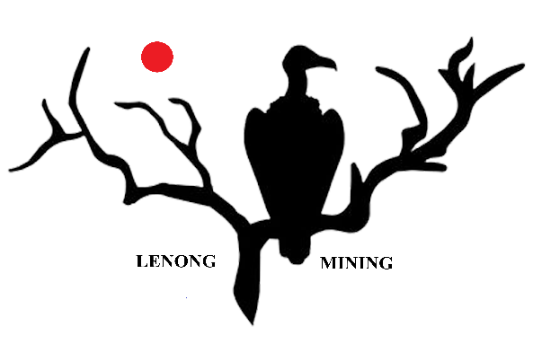 Reg no: 2003/000138/07

Vat no: 4300204346

P.O. Box 1541, Brits, 0250

Tel: 012 257 6334

Cell: 083 628 5534

jan-louis@cdsmining.co.za;

craffie@cdsmining.co.za

19/02/2025

**Mr. JL Swartz**  
Municipality Manager  
Nama Khoi Municipality  
4 Namakwa street  
Springbok 8240

Dear Mr. Swartz

I hope this letter finds you well.

I am writing to introduce our company, **Lenong Mining**, to Nama Khoi Municipality. We have been active in the mining industry since 1989, primarily specializing in the extraction of dimension stone blocks. Our operations have been based in the Brits, North West area, where we have successfully supplied quality stone to various industries over the years.

We are currently looking to expand our operations to **Eendorn Farm, Karehoute Kloof 221**, and believe there is significant potential for collaboration within your jurisdiction. We are keen to come to an agreement regarding this area.If an agreement is reached,we propose a monthly rental of ZAR40000 for the 5Ha where the operation will be conducted aswell as the buildings. We also propose a ZAR4000 per block when sold. There are approximately 200 blocks lying on the ground. That will give you the total sum of ZAR800000 if the market accepts the material.

We see the opportunity to contribute positively to the local economy through sustainable mining practices.

We would welcome the opportunity to meet with you and further discuss how Lenong Mining can play a role in the continued growth and development of the Nama Khoi region. Please feel free to contact us at any of the following email addresses for further communication:

* craffie@cdsmining.co.za
* craffie.crafford@gmail.com
* [tobias.jagla@googlemail.com](mailto:tobias.jagla@googlemail.com)

Alternatively, please let us know a convenient time to schedule a meeting or if any additional information is needed.

Thank you for your time and consideration. We look forward to the opportunity to engage with you.

Sincerely

Theodorus Ernst Crafford  
MD  
Lenong Mining  
0836285534  
craffie@cdsmining.co.za