

**Nama Khoi Municipality**

**14 January 2022**

**MUNICIPAL FINANCE MANAGEMENT ACT (MFMA): MONTHLY REPORT FOR THE PERIOD ENDING 31 January 2022 (MONTHLY BUDGET STATEMENT) – 2022/2022 FINANCIAL YEAR.**

1. **PURPOSE**

71. (1) The accounting officer of a municipality must by no later than 10 working days after the end of each month submit to the mayor of the municipality and the relevant provincial treasury a statement in the prescribed format on the state of the municipality’s budget reflecting the financial affairs for that month and the financial year up to the end of that month:

1. **STRATEGIC OBJECTIVE**

The strategic objective of this report is to ensure good governance, financial viability, and optimal institutional transformation with the capacity to execute its mandate.

For the reporting period ended 31 January 2022

**3. QUERIES AND SUGGESTIONS**

**\*The financial services division will appreciate it if all queries and suggestions can be addressed to the Chief Financial Officer in writing.**

**Please note the municipality wish to notify the reader that information is subject to correction as the financial system as part of the municipal ICT environment is currently being rebuilt.**

1. **REPORT FOR THE PERIOD ENDING 31 January 2022**

**This report is based upon financial information, as of 31 January 2022 and available at the time of preparation.**

The financial results for the period ended 31 January 2022 are summarised as follows:

Statement of Financial Performance (SFP) **(Annexure B – TABLE C4)**

The summary report indicates the following:

**Table of Contents**

|  |  |  |  |  |  |  |  |  |  |
| --- | --- | --- | --- | --- | --- | --- | --- | --- | --- |
| Page 3 |  |  |  | Table C4-Financial Performance |  |  |  |  |  |
| Page 4 |  |  |  | CHART 1- Revenue by source |  |  |  |  |  |
| Page 5 |  |  |  | CHART 2 – Expenditure by type |  |  |  |  |  |
| Page 6 |  |  |  | Table C3 – Revenue and expenditure by vote |  |  |  |  |  |
| Page 8 |  |  |  | CHART 3 – Revenue by vote& Variances |  |  |  |  |  |
| Page 9 |  |  |  | CHART 4 – Expenditure by vote& Variances |  |  |  |  |  |
| Page 9 |  |  |  | Capital Expenditure |  |  |  |  |  |
| Page 10 |  |  |  | Cash Flow Statement |  |  |  |  |  |
| Page 11 |  |  |  | Debtors Age Analysis |  |  |  |  |  |
| Page 13 |  |  |  | Creditors age analysis |  |  |  |  |  |
| Page 14 |  |  |  | Employee Related Cost |  |  |  |  |  |
| Page 15 |  |  |  | Financial Implications/Recommendations |  |  |  |  |  |
| Page 16 |  |  |  | Interdepartmental and Cluster Impact |  |  |  |  |  |
| Page 17 |  |  |  | Quality Certificate |  |  |  |  |  |
| Page 18 |  |  |  | Annexure A |  |  |  |  |  |
| Page 20 |  |  |  | C-Schedule Table of contents |  |  |  |  |  |

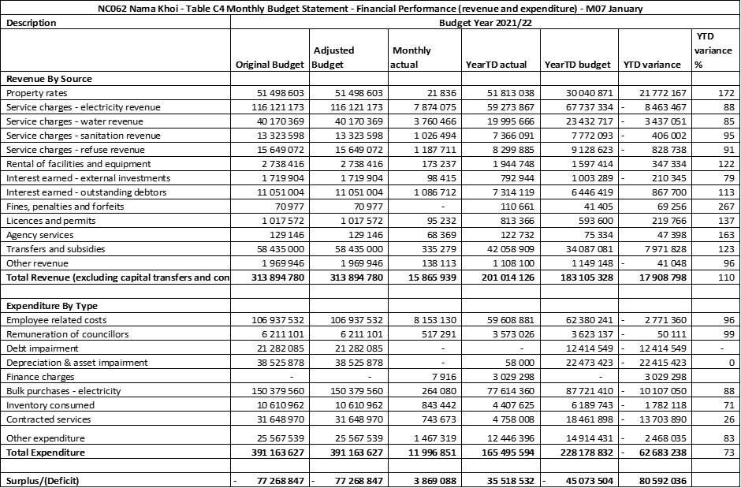



**Explanation on YTD variance % - e.g. 201% means that the municipality billed 101% more than what was budgeted and 98% means the municipality billed 2% less than what was budgeted.**

Variances to be discussed in Institutional and Finance Committee

**Matters of Concern**

Revenue billed should not be seen as actual cash received, the Statement of Financial Performance sometimes gives the reader the idea that the municipality already collected the billed revenue.

Property Rates matter has again remained and it creates the incorrect picture to the Council as well as the reader of the report, Property Rates are billed and it does not necessarily mean actual cash, this issue has been raised numerous times in the past.

Electricity revenue was billed R8.4 million less than the anticipated budget, there are various reasons but more commonly it is found that users used less electricity in some cases as a result of tampering.

Water revenue is already less than budgeted, with the huge outstanding Sedibeng Water bill it is of the utmost importance that the billing as well the losses of water be addressed.

Rental of facilities is above the anticipated revenue, it must be noted that the municipality had appointed a dedicated official, the official has started to revive the rental reconciliation and collection thereof, this function was not fully implemented in the previous financial year.

Interest from outstanding debtors is more than the budget this means that debtors keep on increasing, the interest does not necessarily result in cash.

Fines and licenses &permits – varies from month to month and is difficult to budget.

Revenue from sources other than service charges only amounts to 5% of the total monthly revenue.

**CHART 1**

**The following chart shows the revenue by source for the month of 30 January 2022 in terms of revenue as a percentage of total revenue.**

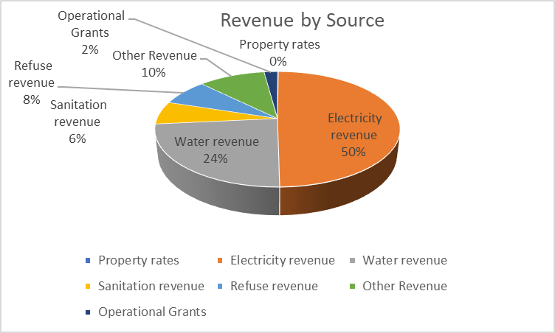

**Notes on variances above/under 10%**

Variances to be discussed in Institutional and Finance Committee



**Matter of Concern**

Bulk Electricity – Municipality paid less in actual cash than was budgeted, it should be however noted that are differences between ESKOM bill and Nama Khoi Mun to the community with the municipality earning less revenue and therefore struggling to adhere to the monthly obligations.

It must also be noted that the municipality incorrectly included Bulk Water in the R150 379 560, it should’ve been budgeted for under inventory consumed, the expenditure incurred for water is not reflected in the expenditure report and is therefore understated. Please see the invoices received and the payments made thereof. Correction must be done at the Adjustment Budget.

Debt Impairment and Depreciation - At this point municipality is still processing journals manually at year-end and therefore no figure is illustrated at the Mid-Year Stage.



Finance Charges – Municipality is still paying for penalties on the ESKOM account

Contracted Services and Other Expenditure – these expenditures are reliant on a positive cash flow, due to the municipality’s poor cash flow over the last few months the municipality was not able to attend to day-to-day operations as budgeted.

**CHART 2**

**The following chart shows the expenditure by type in terms of expenditure at a percentage of total expenditure, Chart as per the information above**

**Expenditure by Type**

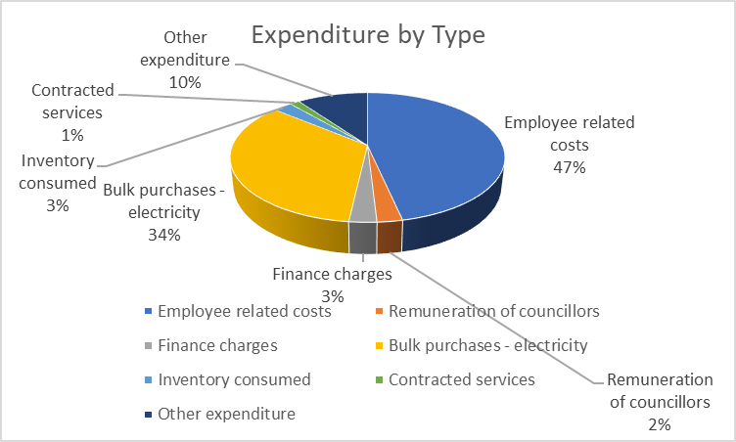

**The table below indicates revenue and expenditure by vote**

**Annexure B – Table C2**



**Reasons for variances above/under 10%**

Variances to be discussed in Institutional and Finance Committee

**CHART 3**

**The following chart shows the revenue by vote for 31 January2022**



**Notes on Table Above**

Revenue billed does not necessarily mean the monies has collected the actual cash

Water bulk water/inventory must be corrected with the Adjustment Budget

It must be noted Revenue by function includes capital revenue recognized resulting in the difference when compared to revenue by source.

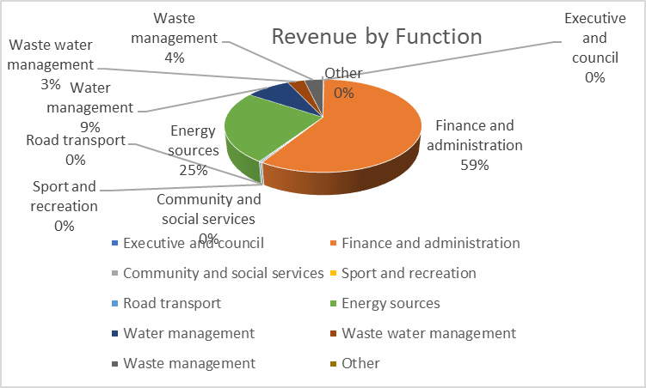

**CHART 4**



**Notes on the table above**

As stated on the face of the report the municipality had experienced some challenges with the financial system for the 2022-22 financial year and even in the previous financial year for that reason, there might be figures that do not necessarily illustrate the correct figures.

When comparing the new MSCOA reports to the old reports before MSCOA there are some differences, however, all transactions are done through the necessary SCM procedures.

As stated in the previous expenditure report bulk water is now stated as water inventory does not reflect correctly and the correct figures are illustrated above.

**The following chart shows the expenditure by vote for 31 January2022**

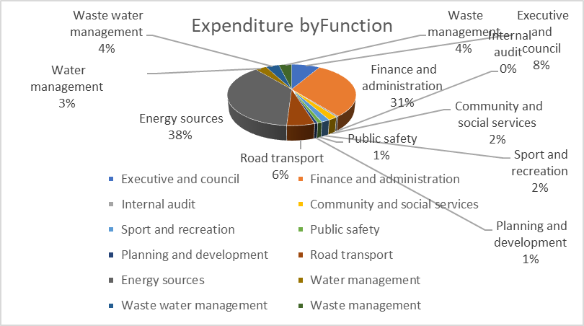

**Reasons for variances above/under 10%**

Variances to be discussed in Institutional and Finance Committee

**Capital expenditure report (Annexure B – Table C5)**

**The Capital expenditure report shown in Annexure B has been prepared based on the format required by the National Treasury.**

**Please note Capital Expenditure subject to correction**



Capital projects and expenditure will be submitted by the Technical Departments, projects and progress will also be discussed by the Technical Department

**CASH FLOW STATEMENT AT 31 January2022**



**Notes on the Cash Flow Statement**

Please note the Cash Flow Statement currently does not reflect the true reflection of the cash received and payments made.

Cash and Cash equivalents at the year-end figure, therefore, be discarded

The matter will be escalated to the Service Provider and will be discussed during the Mid-Year Assessment session with State Departments.



Collection Rate shows the municipality collected 94.52% of billed revenue for December, it should, however, be noted that the monies received include outstanding debt and the municipality only collected 6.46% of all outstanding debt.

**Debtors Age Analysis - Annexure B -Table SC3**

**The debtor’s age analysis report shown in Annexure B has been prepared based on the format required by the National Treasury. The following report shows the debtor’s outstanding on 30 January2022.**



Debtor’s outstanding for more than 121 days amounts to R249 040 244

Debtors are increasing every month if the period is more than 60 days and 90 days are checked it is clear there is a constant increase, on the debtor’s books there are many disputes which result in no or low payments on accounts. Several action plans and debt collection procedures have been introduced in the past but have not been successful. Debt control reports will be submitted to show the success and challenges of recovering debt.

**Chart 8 – Debtors per revenue source**



**The following chart shows the debtors outstanding per revenue source, Chart as per the information above**

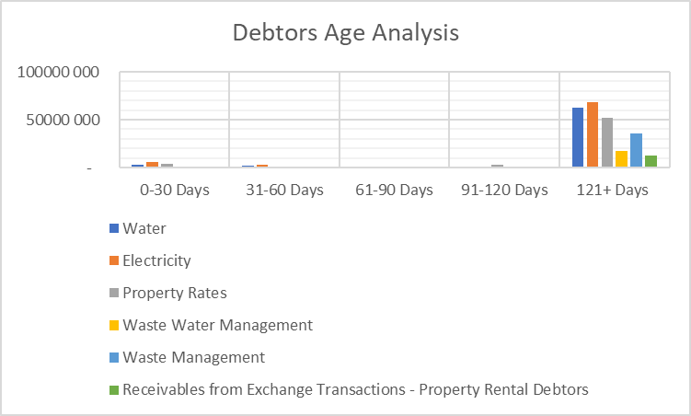

**Debtor Age Analysis by Category**



**CHART 9**

**The following chart shows the debtors outstanding per category, Chart as per the information above.**

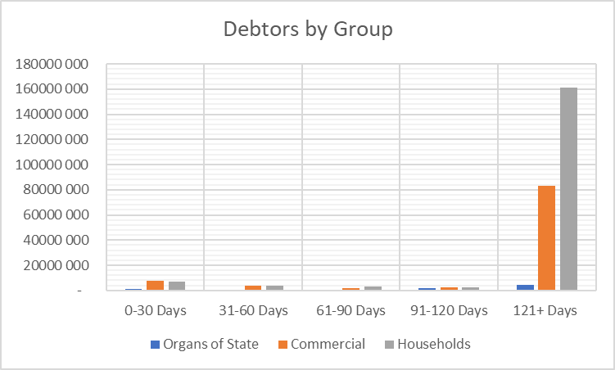

**CREDITORS Age Analysis - Annexure B -Table SC4**

**The creditor’s age analysis report shown in Annexure B has been prepared based on the format required by the National Treasury.**

**The following report shows the creditor’s outstanding on 31 January2022.**



**Creditors Analysis**

Please note creditors report is subject to correction

From the creditors’ age analysis, it is clear that the municipality has two main creditors namely ESKOM and Sedibeng, for the past six months the municipality has managed to almost keep up with the invoices from Sedibeng, however, the winter months for ESKOM are just out of reach for the municipality, detailed report on Sedibeng and ESKOM will be tabled with the Mid-Year Assessment Report.

It is important to note that the municipality electricity revenue does not only consist of pre-paid electricity and the municipality must also collect the conventional part. There are also quite a few customers that benefitted from faulty meters, corrections must be implemented as a matter of urgency. Municipality at this stage is running the electricity department at a loss which is hampering the municipality’s ability to settle the ESKOM account.



**MFMA 66.** The accounting officer of a municipality must, in a format and for periods as Januaryprescribed, report to the council on all expenditure incurred by the municipality on staff salaries, wages, allowances, and benefits, and in a manner that discloses such expenditure per type of expenditure, namely:

*(a)* salaries and wages;

*(b)* contributions for pensions and medical aid;

*(c)* travel, motor car, accommodation, subsistence, and other allowances;

*(d)* housing benefits and allowances;

*(e)* overtime payments;

*(f)* loans and advances; and

*(g)* any other type of benefit or allowance related to staff.

***Employee-related cost to total expenditure*** % of an organization should be at 25-40% of total expenditure, the ratio for January2022 is 47%.

1. **Financial Implications /Recommendations**

**Revenue by Type:**

Service Delivery departments are not sustainable, tariff structures must be increased and other fees related to service also need to increase. With the current high rate of unemployment in the Nama Khoi region further increase of service will only add to the burden of the community, for that reason the municipality should focus on collecting the current and outstanding debt. The municipality should focus on correct accounts to consumers, timely submission of municipal bills should also prioritize. The municipality should also seek assistance from State Departments to ensure it will benefit from all the possible economic developments in the municipal area.

**Expenditure by type:**

The municipality should make the financial recovery plan a working document, each activity should be monitored and regularly be reported on. Expenditure and service delivery should be prioritized, the municipality should invest in new fleet rather than spending monies on repairing fleet that is not sustainable, modern methods of distributing accounts should be explored, savings on telephone cost, traveling & subsistence, refreshments, printing & stationery, fuel, etc must be implemented.

**Capital Expenditure:**

Capital expenditure should be aligned to the approved DORA payment schedule. The department should re-assess on projects to determine if they are still in line for 100% expenditure by the end of the Financial Year. All necessary processes should be fast-tracked in line with all the required legislation and with the guidance of the respective department.

**Cash Flow Statement:**

Expenditure should be linked to the cash flow budget, once cash is less than budget corrections must be done to avoid the municipality running into cash flow problems. The municipality should strive to use the cash received wisely and for the intended purpose as planned. The municipality should strive to spend less cash than it has received to avoid going into a negative cash balance. Revenue/Cash recovery must be structured in a manner that the old outstanding funds received will be used to either settle outstanding creditors or to fund projects that can enhance revenue recovery.

**Debtors Analysis**

100% billing of correct accounts for all debtors in the Nama Khoi area should be prioritized. Constant debt collecting and implementation of credit control should be communicated to the community. Interdepartmental communication needs to be improved. Constant notifications to the community must improve. Community members should be invited to resolve old outstanding issues.

**Creditors Analysis**

The municipality must adhere to paying monthly creditors on time, old outstanding debt must be prioritized and linked to the Reviewed Financial Recovery Plan. Intervention is needed with regards to outstanding debt of bulk services. The municipality should strive to receive accounts that can be serviced every month and therefore communication between all relevant parties is vital.

**General Note**

Historical problems at Nama Khoi Municipality should be resolved, this includes old and depleted infrastructure, litigation issues, creditors, and debtors with disputes. The system-related issues must be resolved as soon as possible, it is also important that the issues with the Expenditure, Capital Reports, Cash Flow Statement as well as the Creditors Age Analysis be resolved with the Financial System Service Provider.

**6. Interdepartmental and cluster impact**

This report is prepared to achieve MFMA compliance.

**7. Comments of the Head: Legal Services**

The above-mentioned report as such does not call for legal clarification

**8. Conclusion**

This report was compiled in accordance compliance with section 71 of the MFMA, by providing a statement to the Council containing certain financial particulars

**Prepared By:**

Heinri Cloete

Chief Financial Officer

**NAMAKHOI MUNICIPALITY QUALITY CERTIFICATE**

Samantha Tatas-Titus

I, …………………………………., the Municipal Manager of Nama Khoi Municipality, hereby certify that –

* The monthly report on the implementation of the budget and financial state affairs of the municipality for the month ending 30 January2022 has been prepared by the Municipal Finance Management Act 71 and regulations made under that Act.

**Print Name: SAMANTHA TATAS TITUS**

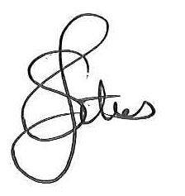Municipal Manager of Nama Khoi Municipality

Signature:…………………………………………………………….

14 Feb 2022

Date: ………………………………………………

**Annexure A**

**Reports and reportable matters**

**Monthly reports statements – Section 71 MFMA**

(1) The accounting officer of a municipality must no later than 10 working days after the end of each month submit the relevant provincial treasury a statement in the prescribed format on the state of the municipality’s budget reflecting the following particulars for that month and the financial year up to the end of that month:

(a) Actual revenue, per revenue source

(b) Actual borrowings

(c) Actual expenditure per vote

(d) Actual capital expenditure per vote

(e) The amount of any allocations received

(f) Actual expenditure on those allocations, excluding expenditure on –

(i) Its share of the local government equitable share, and

(ii) Allocations exempted by the annual Division of Revenue Act from compliance with this paragraph; and

(g) When necessary, an explanation of –

(i) Any material variances from the municipalities projected revenue by source, and from the municipality’s expenditure projections per vote;

(ii) Any material variances from the service delivery and budget implementation plan; and

(iii) Any remedial or corrective steps taken or to be taken to ensure that projected revenue and expenditure remain within the municipality’s approved budget

(2) The statement must include –

(a) A projection of the relevant municipality’s revenue and expenditure for the rest of the financial year, and any revisions from initial projections; and

(b) The prescribed information relating to the state of the budget of each municipal entity as to the municipality in terms of section 87 (10)

(3) The amounts reflected in the statement must in each case be compared with corresponding amounts budgeted for in the municipality’s approved budget

(4) The statement to the provincial treasury must be in the format of a signed document and the electronic format.

(5) The accounting officer of a municipality which has received an allocation referred to in subsection (1) (e) during any particular month must by no later than 10 working days after the end of that month, submit that part of the statement reflecting the particulars referred to in subsection (1) (e) and (f) to the national or provincial organ of state or municipality which transferred the allocation.

(6) The provincial treasury must by no later than 22 working days after the end of each month submit to the National Treasury a consolidated statement in the prescribed format on the state of the municipalities’ budgets per municipality and municipal entity

(7) The provincial treasury must, within 30 days after the end of each quarter, make public as October prescribed, a consolidated statement in the prescribed format on the state of municipalities’ budget per municipality and per municipal entity. The MEC for finance must submit such consolidated statements to the provincial legislature no later than 45 days after the end of each quarter.

